**A2135, A2147**- Asia-Parthian Empire-Light Horse Cavalryman and Rider-247 BCE – 224 CE

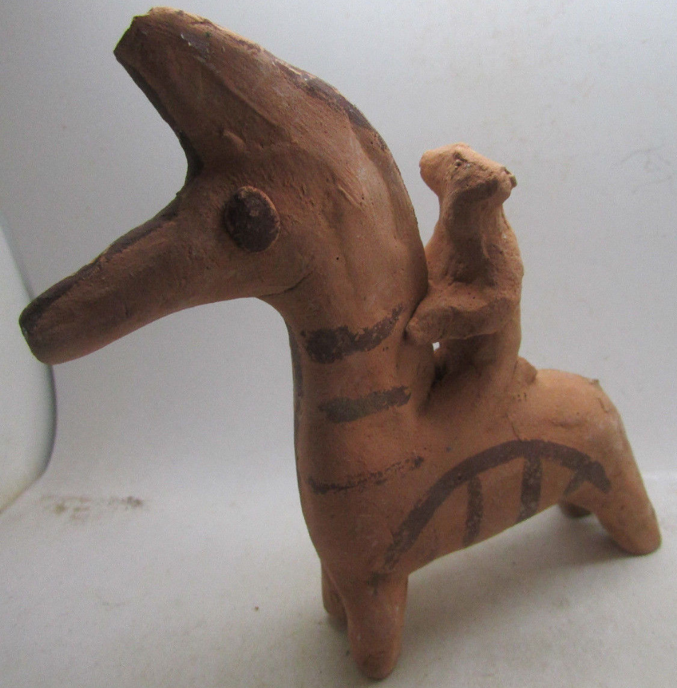

Figs. 1-2. Asia-Parthian Empire-Light Horse Cavalryman and Rider-247 BCE – 224 CE

**Case no.: 4**

**Accession Numbers: A2135, A2147**

**Formal Label:** Asia-Parthian Empire-Light Horse Cavalryman and Rider-247 BCE – 224 CE

**Display Description:**

The rôle of the light horse cavalry played a significant tactical and strategic rôle in the establishment of the Parthian or Arsacid Empire (247 BCE – 224 CE) by Arsaces I of Parthia of the Parni tribe. Under Mithridates I (r. c. 171–138 BCE) Parthia used the light horse cavalryas an advance force to destabilize the enemy in order to expand from N Mesopotamia to E Persia. The Silk Road was the commercial conduit through Parthia that connected the Roman Empire to Han China, and it was this connection that made Parthia a focal point of trade, commerce and cultural diversity. Parthian culture was a syncretism of Persian, Hellenistic and Roman elements. Furthermore, Parthia accepted local rulers as vassals, thereby preserving local cultures and furthering Parthian syncretism. The Seleucids and the Armenians and finally the late Roman Empire were contenders for military, political and commercial power in the west while the Scythians were military enemies in the east.

The light horse cavalry played a significant tactical rôle in the defeat of Marcus Licinius Crassus at the Battle of Carrhae in 53 BCE, when it led the charge against his advance troops. This victory helped to establish a military tension between Parthia and Rome that resulted in a sporadic military contest that lasted for two centuries. During this period the light horse cavalry played a significant tactical rôle that helped to establish Parthia as a major military contender in the area from the Levant to E Persia.

**LC Classification:**  [DS329.P2](http://josiah.brown.edu/search~S7?/cDS329.P2+R2+1901/cds++329+p2+r2+1901/-3,-1,,E/browse)

**Date or Time Horizon:** 247 BCE – 224 CE

**Geographical Area:** Parthia

**Map:**



Fig. 3. The region of Parthia within the empire of Medes, c. 600 BCE; from Shepherd 1926.

**GPS coordinates: 60E, 35 N**

**Cultural Affiliation:** Parthia

**Media:** terracotta, black slip.

**Dimensions:** H 117.77 mm, 4.64 in

**Weight: 89 gm, 3 1/8 oz**

**Condition: original**

**Provenance:** old French collection

**Discussion:**

Parthia encompassed much of the Median Empire by the first century CE. Much of this expansion was due to the effectiveness of the light horse cavalry in opening advances through the first lines of the enemy’s forces through which the heavy horse cavalry could penetrate the enemy’s second lines of defense.

|  |
| --- |
| [Click image to enlarge](http://www.parthia.com/images/lighthorse.gif) |
| Parthian Light Horse Cavalryman showing the use of the Scythian double curve bow in battle. Light horse cavalry made use of the double curve bow, but heavy infantry on horseback were limited in movement due to the weight of iron mail and therefore preferred the lance. Graffiti from a private house, Dura Europos, Syria. Before 249 CE. After M. Rostovzeff, *et al.* 2007: fig. 2. |

---------------------------------------------------------------------------------------------------------------------

**References:**

Altimira, Rafael (trans. By Muna Lee). *A History of Spain* (Toronto: D. Van Co., 1949)

Arribas, Antonio. *The Iberians*. (New York: Frederick A. Praeger, 1963)

Ashberry, A. J. *The Legacy of Persia*. (Oxford: Oxford University Press, 1953/1963)

Browning, Robert. *Justinian and Theodora* (New York: Frederick A. Praeger, 1971)

Culican, William. *The Medes and Persians*. (New York: Frederick A. Praeger, 1965)

Forte, Nancy. *The Warrior in Art*. (Minneapolis, MN: Lerner Pub., 1966)

Haussig, H. W. (trans. by J. W. Hussey).*A History of the Byzantine Civilization*. (New York: Frederick A. Praeger, 1966/1971)

Hopkins, Edward C. D. [The Parthian Empire](http://www.parthia.com/) (web site)

McNulty, Henry. "The Horses of Jerez", *Gourmet*, June 1983

Ogata, Osamu. The Origins of "Yabusame" (Horseback Archery), 10 Jan 95 (web page)

Payne, Robert. "The Parthians" in *The Splendor of Persia*. (New York: Alfred A. Knopf, 1957)

Rice, Tamara Talbot. *The Scythians*. (New York: Frederick A. Praeger, 1957)

Rostovzeff, Michael Ivanovitch; David Talbot Rice; Tamara Talbot Rice.  2007. *Caravan Cities. N.P.:* Rostovtzeff Press.

Roux, Georges. *Ancient Iraq*. (New York: The World Pub. Co., 1964)

Shepherd, William Robert.1926. *Historical Atlas*, 5th ed. New York: Henry Holt.

Smith, Andrew. N.d. ["Justinus: Epitome of Pompeius Trogus](C:\\Users\\murcott\\Desktop\\2018-March\\\"Justinus: Epitome of Pompeius Trogus (7)\")

[(7)"](C:\\Users\\murcott\\Desktop\\2018-March\\\"Justinus: Epitome of Pompeius Trogus (7)\").  http://www.attalus.org/translate/justin7.html#41.1 )

Varley, Victoria. President, [The Tiger Horse Registry](http://www.tigrehorse.com/) (web site)

Wild, Oliver. [The Silk Road](http://www.ess.uci.edu/~oliver/silk3.html) (web page)

[Yabusame](http://www.japanpage.org/photo/yabusame.htm), or Japanese horseback archery (web page)

Zuelke, Ruth. *The Horse in Art*. (Minneapolis, MN: Lerner Pub., 1965)